Danh Thùy Linh

Bài 1:

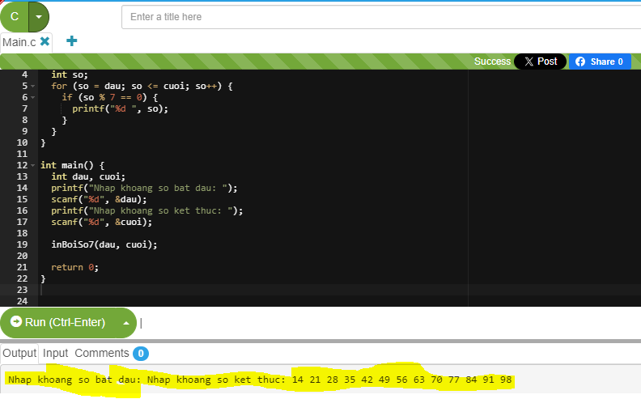

Link Source code bài 1:

<https://paiza.io/projects/3A9NCSjmgL4_w4p6c_x-8Q?language=c>

bài 2:

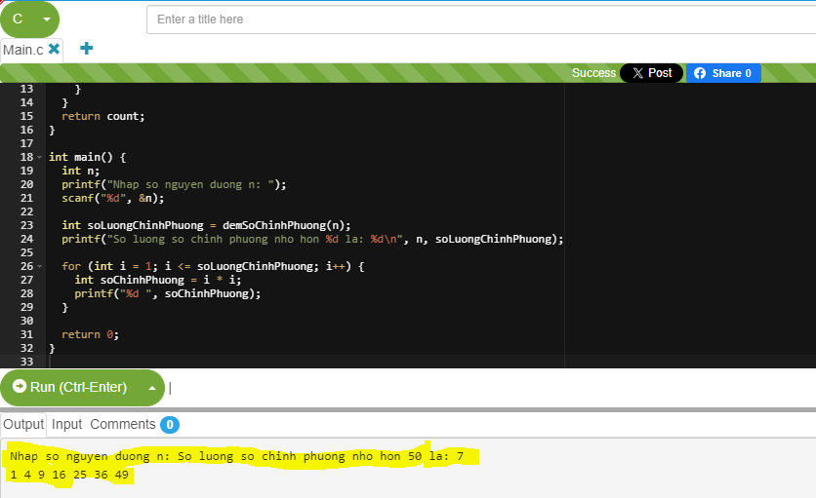

Link Source code bài 2:

<https://paiza.io/projects/jBTbgSDiJMRH4petVfcaPQ?language=c>

bài 3:

<https://stark-striking-elk.anvil.app>